Assignment -02
Task 01: Please conduct multiple Protein-Ligand Docking and provide the top 10 results in the following table.

 | Ligands | Binding Affinity | Rmsd/ub | Rmsd/ib
01 | 2z66_COMPOUND_CID_5280343_uff_E=379.98 | -9.4 | 0 | 0
02 | 2z66_COMPOUND_CID_6037_uff_E=304.84 | -8.6 | 0 | 0
03 | 2z66_COMPOUND_CID_4970_uff_E=724.47 | -7.9 | 0 | 0
04 | 2z66_COMPOUND_CID_5315468_uff_E=179.08 | -6.6 | 0 | 0
05 | 2z66_COMPOUND_CID_493570_uff_E=315.54 | -6.4 | 0 | 0
06 | 2z66_COMPOUND_CID_10364_uff_E=78.47 | -6.1 | 0 | 0
07 | 2z66_COMPOUND_CID_10104370_uff_E=146.42 | -5.9 | 0 | 0
08 | 2z66_COMPOUND_CID_3314_uff_E=170.20 | -5.9 | 0 | 0
09 | 2z66_COMPOUND_CID_10281_uff_E=62.47 | -5.8 | 0 | 0
10 | 2z66_COMPOUND_CID_6989_uff_E=95.97 | -5.8 | 0 | 0

Task 02: Please perform ADME analysis on the 10 compounds obtained from the Protein-Ligand Docking and provide the results in the table below.
ADME Analysis |  |  |  |  |  |  |  | Pharmacokinetics |  | Drug likeness | Medicinal Chemistry
Name | CID ID | Canonical SMILES | Molecular weight | Num. H-bond acceptors | Num. H-bond donors | Lipophilicity (iLOGP) | Water Solubility (Log S (SILICOS-IT)) | GI absorption | BBB permeant | Lipinski | PAINS
Quercetin | 5280343 | C1=CC(=C(C=C1C2=C(C(=O)C3=C(C=C(C=C3O2)O)O)O)O)O | 302.24 | 7 | 5 | 1.63 | -3.24  Soluble | High | No | Yes; 0 violation | 1 alert: catechol_A
(2S)-2-[[4-[(2-amino-4-oxo-1H-pteridin-6-yl)methylamino]benzoyl]amino]pentanedioic acid | 6037 | C1=CC(=CC=C1C(=O)N[C@@H](CCC(=O)O)C(=O)O)NCC2=CN=C3C(=N2)C(=O)N=C(N3)N | 441.4 | 9 | 6 | -0.25 | -4.60  soluble | Low | No | No; 2 violations: NorO>10, NHorOH>5 | 0  alert
Protopine | 4970 | CN1CCC2=CC3=C(C=C2C(=O)CC4=C(C1)C5=C(C=C4)OCO5)OCO3 | 353.4 | 6 | 0 | 3.19 | -5.38  Moderately soluble | High | Yes | Yes; 0  violation | 0  alert
(E)-alpha-bisabolene | 5315468 | CC1=CCC(CC1)/C(=C/CC=C(C)C)/C | 204.35 | 0 | 0 | 3.49 | -3.21  soluble | Low | No | Yes; 1 violation: MLOGP>4.15 | 0  alert
Riboflavin | 493570 | CC1=CC2=C(C=C1C)N(C3=NC(=O)NC(=O)C3=N2)C[C@@H]([C@@H]([C@@H](CO)O)O)O | 376.4 | 8 | 5 | 1.63 | -2.62  Soluble | Low | No | Yes; 0 violation | 0  alert
Carvacrol | 10364 | CC1=C(C=C(C=C1)C(C)C)O | 150.22 | 1 | 1 | 2.24 | -3.01  soluble | High | Yes | Yes; 0 violation | 0  alert
Beta-Bisabolene | 10104370 | CC1=CC[C@H](CC1)C(=C)CCC=C(C)C | 204.35 | 0 | 0 | 3.67 | -3.58  soluble | Low | No | Yes; 1 violation: MLOGP>4.15 | 0  alert
Eugenol | 3314 | COC1=C(C=CC(=C1)CC=C)O | 164.20 | 2 | 1 | 2.37 | -2.79  Soluble | High | Yes | Yes; 0 violation | 0  alert
Thymoquinone | 10281 | CC1=CC(=O)C(=CC1=O)C(C)C | 164.20 | 2 | 0 | 1.99 | -2.03  soluble | High | Yes | Yes; 0 violation | 1 alert: quinone_A
Thymol | 6989 | CC1=CC(=C(C=C1)C(C)C)O | 150.22 | 1 | 1 | 2.32 | -3.01  soluble | High | Yes | Yes; 0 violation | 0  alert

Task 03: Perform Toxicity Prediction on the 10 compounds obtained from the Protein-Ligand Docking and provide the results in the table below.
Toxicity Prediction
Name | CID ID | Canonical SMILES | Hepatotoxicity | Carcinogenicity | Immunotoxicity | Mutagenicity | Cytotoxicity
Quercetin | 5280343 | C1=CC(=C(C=C1C2=C(C(=O)C3=C(C=C(C=C3O2)O)O)O)O)O | 0.69  Inactive | 0.68  Active | 0.87  Inactive | 0.51  Active | 0.99  Inactive
(2S)-2-[[4-[(2-amino-4-oxo-1H-pteridin-6-yl)methylamino]benzoyl]amino]pentanedioic acid | 6037 | C1=CC(=CC=C1C(=O)N[C@@H](CCC(=O)O)C(=O)O)NCC2=CN=C3C(=N2)C(=O)N=C(N3)N | 0.97  Inactive | 0.56  Inactive | 0.99  Inactive | 0.81  Inactive | 0.74  Inactive
Protopine | 4970 | CN1CCC2=CC3=C(C=C2C(=O)CC4=C(C1)C5=C(C=C4)OCO5)OCO3 | 0.92  inactive | 0.60  active | 0.53  active | 0.53  active | 0.57  inactive
(E)-alpha-bisabolene | 5315468 | CC1=CCC(CC1)/C(=C/CC=C(C)C)/C | 0.82  inactive | 0.76  inactive | 0.84  inactive | 0.91  inactive | 0.82  inactive
Riboflavin | 493570 | CC1=CC2=C(C=C1C)N(C3=NC(=O)NC(=O)C3=N2)C[C@@H]([C@@H]([C@@H](CO)O)O)O | 0.93  inactive | 0.75  inactive | 0.94  inactive | 0.72  inactive | 0.75  inactive
Carvacrol | 10364 | CC1=C(C=C(C=C1)C(C)C)O | 0.75  inactive | 0.60  inactive | 0.96  inactive | 0.99  inactive | 0.89  inactive
Beta-Bisabolene | 10104370 | CC1=CC[C@H](CC1)C(=C)CCC=C(C)C | 0.82  inactive | 0.74  inactive | 0.60  inactive | 0.93  inactive | 0.81  inactive
Eugenol | 3314 | COC1=C(C=CC(=C1)CC=C)O | 0.67  inactive | 0.73  inactive | 0.83  inactive | 0.97  inactive | 0.90  inactive
Thymoquinone | 10281 | CC1=CC(=O)C(=CC1=O)C(C)C | 0.63  inactive | 0.63  inactive | 0.97  inactive | 0.91  inactive | 0.78  inactive
Thymol | 6989 | CC1=CC(=C(C=C1)C(C)C)O | 0.75  inactive | 0.60  inactive | 0.93  inactive | 0.99  inactive | 0.89  inactive

Task 04: Identify the highest-ranking Protein – ligand complex and input the corresponding figures into the table below.
Figure Name | Sample Figure | Input your Docking Figure
Figure 01 | 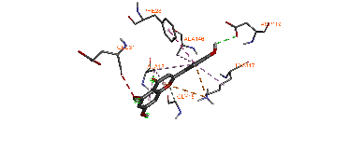 | 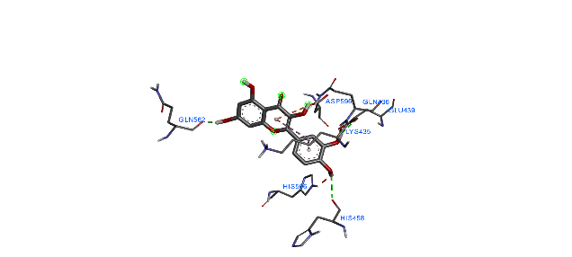
Figure 02 | 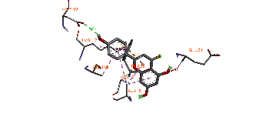 | 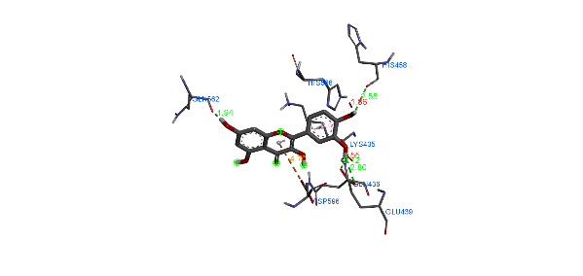
Figure 03 | 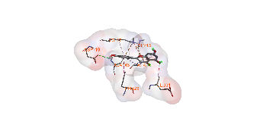 | 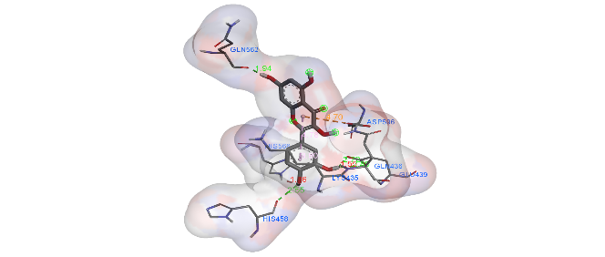
Figure 04 | 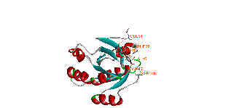 | 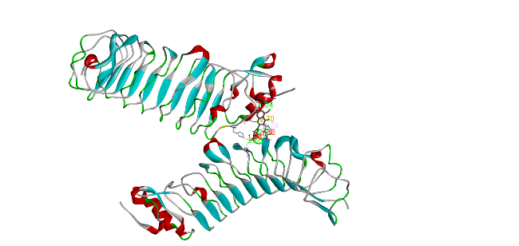
Figure 05 | 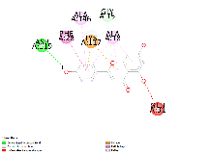 | 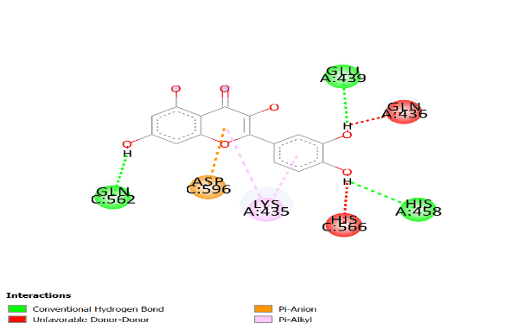

Task 05: Identify the highest-ranking Protein – ligand complex and input the Interaction details into the table below.
Name | Distance | Category | Types
N:UNL1:H - A:GLU439:OE1 | 2.80102 | Hydrogen Bond | Conventional Hydrogen Bond
N:UNL1:H - A:GLU439:OE2 | 2.72478 | Hydrogen Bond | Conventional Hydrogen Bond
N:UNL1:H - A:HIS458:O | 2.55074 | Hydrogen Bond | Conventional Hydrogen Bond
N:UNL1:H - C:GLN562:O | 1.93804 | Hydrogen Bond | Conventional Hydrogen Bond
C:ASP596:OD2 - N:UNL1 | 4.7031 | Electrostatic | Pi-Anion
N:UNL1 - A:LYS435 | 4.78097 | Hydrophobic | Pi-Alkyl
N:UNL1 - A:LYS435 | 3.80002 | Hydrophobic | Pi-Alkyl

Summary:
Task 1:
The name of assigned protein is 2z66. This protein goes to multiple ligand docking process. Among 25 ligand compounds
(2z66_COMPOUND_CID_5280343_uff_E=379.98 ) complex show the highest binding affinity and that is -9.4
This multiple protein ligand docking is performed in PyRx software

Task 2: ADME analysis
The best docking ligand compound is Quercetin, CID 5280343.

Canonical SMILES: C1C2=C(C(=O)C3=C(C=C(C=C3O2)O)O)O)O)O C1=CC(=C(C=
Molecular weight: 302.24
Num. H-bond acceptors: 7
Num. H-bond donors: 5
Lipophilicity (iLOGP): 1.63
Water Solubility (Log S (SILICOS-IT)): -3.24, soluble
GI absorption: High
BBB permeant: No
Drug likeness Lipinski: Yes; 0 violation
Medicinal Chemistry (PAINS): 1 alert: catechol_A

Task 3: Toxicity analysis
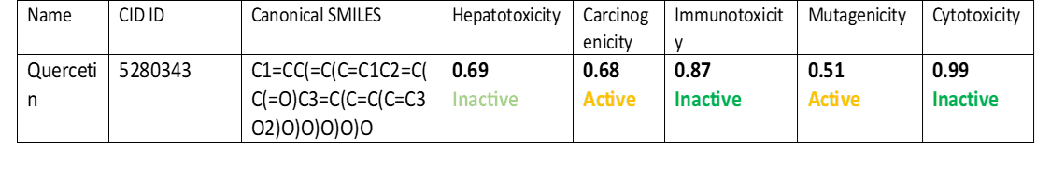
In case of toxicity result analysis hepatotoxicity, immunotoxicity, and cytotoxicity is inactive but carcinogenicity and mutagenicity is active. So this ligand is not suitable for drug design.

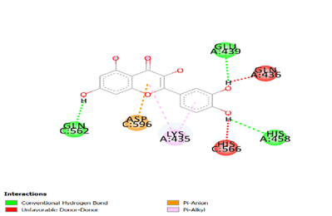
Figure of Proteins ligand interaction: 2D diagram

Protein – ligand complex and the Interaction:
In this Protein – ligand complex there are 4 hydrogen bond, 1 electrostatic bond, 2 hydrophobic bond is present.

